* The environment
  + FOR MOST PODS 1
  + For the work trays 2
* 3 different Java Scripts calls to go to different places
  + From chart to page 6
  + From page 6 to page 6
  + From chart/page 6 to application 512
* The charts
  + Bar, 2 ways to show stacks
    - By series
    - By columns
  + Labels, sizes
* The table
* The drill down
* The drill down to application 512
* X_get_im_user_id
* 512
  + Copying a page
  + Change the query
  + Making a button
    - Populating the HTML for the button popup
    - Creating functions for the DB population

Creating a Stacked Bar Chart POD (one series)

* Simple, one query (top level, chart)
  + Query should output, 3 columns, in order, the bale doesn’t matter in this case.
    - Link, What, count
  + Sending the chart to page 6
    - Javascript:doDrillDown(podname, :P6_PARAM1, :P6_PARAM2 …)
      * Podname and options need to be text in the query output
  + IM41040 is a good example of this
* Drill Down 1
  + To go from here to another table or chart doDrillDown needs to be part of an HTML Link.
* Drill down 2
  + As an example we have a second level drill down
  + We could have more levels if we wanted too.

Creating a Stacked Bar Chart POD (MultiSeries)

* Using a date range
* Opening application 512
  + showWOWTDrillDown(Application number, unused, pagenumber, pg var name 01, Value, pg var name 02, Value …)
* Edit button
  + Link from IR page
  + 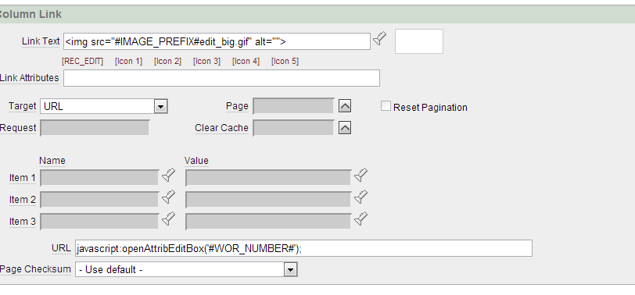
  + javascript:openAttribEditBox('#WOR_NUMBER#');
    - this is found in the html header for the page
* edit button html,